Chapter 16

JIT, Lean Operations and the Toyota Production System

**Background**

Just-in-time (JIT) has been alluded to throughout the book, and we finally see its full treatment here in Chapter 16. Instructors should emphasize that JIT is a *philosophy* of continuous problem solving that drives out waste. It is not a set of techniques or just something about kanbans or small lot sizes. JIT should be thought of as journey towards a long-term goal of working in a completely lean operation. For example, pure JIT might suggest lot sizes of one unit, but in practice we more often think of *moving towards* JIT and *reducing* lot sizes. At its heart, JIT glorifies *procrastination*, a concept with which many students live daily. But the key to *effective* procrastination is eliminating the causes (variability, waste, errors) that would otherwise encourage early completion of any task. Without any problems or variability, we don’t need any safety stock, safety capacity, or safety time.

This chapter covers many issues. Perhaps two of the more important concepts to emphasize with students are the boat picture (Slides 36-39) and the idea of treating setup cost (or time) as a decision variable rather than as a parameter (Slides 40-45). The book also provides a nice set of specific tactics for the operations manager covering JIT layout, JIT inventory, JIT scheduling, and JIT quality (Slides 30, 35, 47, and 60, respectively, corresponding to Tables 16.1 through 16.4). Whether called JIT, TPS, lean, six-sigma, or TQM, the concepts presented in this chapter have redefined the way in which businesses think and operate. These concepts may someday be present in virtually all successful companies.

**Class Discussion Ideas**

1. A powerful example of setup time reduction is the process of changing tires. When we get a flat tire, we have to change it, taking 10 minutes or more, and then we drive to the tire store to fix or replace the flat. Usually the process takes at least one hour. In a car race, however, *all four* tires are changed in a matter of seconds (recall the Global Company Profile in Chapter 10). Every lost second represents about 500 yards of distance in the race, so a fast setup time is critical for success. Clearly, with enough investment and ingenuity, most setup times can be reduced. Have students identify some of the changes that were implemented in the car racing world to enable such a fast setup time (these include product design, having replacements available where and when needed, devoting human resources to the task, using automation, etc.). Then note how some of these same ideas can be applied to many different setup tasks in companies.

2. There are several potential disadvantages or risks of implementing JIT, which might preclude companies from pursuing that strategy. After completing the lecture, instructors might ask students if they can think of any such disadvantages. Example include: (1) risk of supply shortage (what if there’s a strike at your supplier’s plant?); (2) no “just-in-case” inventory (safety stock) to cover unforeseen events (fires, absenteeism, snowstorms, etc.); (3) inventory does provide some operational advantages as described in Chapter 12, but those are lost under JIT; (4) potential traffic problems (particularly during the day in big cities—and having multiple deliveries per day adds trucks to the roadways!); (5) increased transportation costs of delivering less-than-truckload quantities frequently; (6) reliance on non-affiliated suppliers (loss of control); (7) potentially more idle workers (envision how taxpayers feel as they drive by the highway construction site with one worker shoveling and the rest observing and chatting about it); (8) dependence on level schedules (which may not always be possible); and (9) a stoppage anywhere because of, say, a broken machine, stops the whole line (because nobody else has any buffer inventory to work on). This discussion would fit very nicely with the end-of-chapter case, “JIT after a Catastrophe.”

**Active Classroom Learning Exercises**

1. Create two identical assembly lines with, say, three stations each. Place a student at each station. Assign relatively simple tasks to the “product,” for example taping, putting Lego blocks together, stapling, etc. Have the tasks for station 1 take about 2 seconds, station 2 take about 6 seconds, and station 3 take about 15 seconds. Station 1 has unlimited raw materials available, while the other stations start empty. Instruct each member of team 1 to work as fast as possible. Instruct team 2 to implement a pull system. Specifically, have a green kanban card for station 3 and yellow card for station 2. Station 3 is to produce as fast as possible, but each time he/she begins working on a new unit, he/she should pass the green kanban card to station 2. Only when station 2 receives the green card should he/she begin production on a new unit. At that point, station 2 should pass the yellow card to station 1. When station 2 completes a product, he/she should place the green card on top of the product and physically pass it to station 3. Similarly, station 1 should only begin work when he/she receives the yellow card. After completing a product, he/she should place the yellow card on top of the product and deliver it to station 2.

To introduce quality issues, for the setup of both lines, change the color of the raw materials at station 1 to red after the 15th unit. Red represents a defect that is only noticeable once it reaches station 3—but don’t tell anyone. Run a simultaneous simulation of production that lasts for five minutes. Offer candy or some small prize to members of the winning team so that the students will work at a good pace. (Other class members could even be allowed to vote for which team they think will win and be promised candy for the right selection.) What should we see? The throughput for both lines should be approximately 20 units (4 units per minute at the bottleneck times 5 minutes). (It doesn’t really matter which team “wins” with respect to throughput because the “costs” incurred by the push team will make it much less profitable—i.e., give candy to everyone in the class!) Two observations should become immediately apparent. (1) Inventory: The push team should have much more inventory—there should be about 30 units of WIP in front of station 3 [(60/6)5 – 20] and about 100 units of WIP in front of station 2 [(60/2)5 – 50]. Meanwhile the pull team should have at most one unit of WIP in front of both stations 1 and 2. (2) Quality: Assuming that station 3 operators were working at about 15 seconds per task, when the quality inspector stops at station 3, he/she should notice about five defective finished products (20 − 15), which were the last ones produced. Now count the total defects in the system. The pull team should have no more than five defective components back in the assembly line (one in front of stations 2 and 3 and one being worked on at each station). The push team, however, should have one for the entire WIP inventory in front of stations 2 and 3 plus those being worked on (about 133 units). Clearly we see a huge waste difference here.

As a side observation, the instructor could ask about the utilization rates of the workers. Students should notice that workers 1 and 2 on the pull team weren’t working for much of the time. Such apparently low utilization rates appear to suggest waste in the system. In practice, (1) the lines could be better balanced, which would increase throughput as well, (2) those workers could be cross-trained to help out at other stations during idle times, which would increase throughput as well, or (3) stations 1 and 2 could be combined, which would eliminate the cost of one person’s job.

2. One classic strategy in Lean Systems is to locate suppliers close to, on occasion right next to, the customer. Have the students split into groups and choose an organization with a geographically diverse supplier base. Each group should develop strategies for how these suppliers can support a Lean System without relocating. Have the groups share their ideas with the class.

**Company Videos**

1. *JIT at Arnold Palmer Hospital (9:15)*

We get to hear about two implementations of JIT at the hospital. First, at the hospital pharmacy, drugs are drawn just-in-time based on actual patient demand and prescriptions written by doctors. Second, supplies for pre-scheduled surgeries are delivered from the outside supplier the same day as the surgery. The hospital performs 45 different types of surgeries, each requiring a different “surgical pack.” The packs are bulky and would take up a huge amount of storage space if extras had to be stored in the hospital for all of the different potential surgery types. Instead, based on the surgery schedule, the first-tier supplier procures all of the needed items from physician approved vendors and organizes the appropriate surgical pack for each surgery to be performed that day. These packs are trucked by 4:00 a.m. to arrive just-in-time. (Note that supplies needed for *emergency* surgeries are stored on-site for the obvious reasons.) Beyond inventory savings, another benefit of receiving these surgical packs to order is that when physician demands for the packs change, there are no extra packs in stock that would have to be reconfigured. For Arnold Palmer Hospital, JIT has resulted in waste reduction, variability reduction, and inventory being pulled only when needed.

Prior to showing the video, instructors might ask students to think about what at a hospital might be managed on a just-in-time basis. Afterwards, the student ideas could be compared to the two implementations at Arnold Palmer Hospital (it would be surprising if anyone would have thought of the surgical pack implementation). Further discussion could focus on the risks of a system like the surgical pack implementation. What contingency plans would need to be in place to handle potential supply disruptions? If a pack were missing any items, how might the delay affect the patient and the patient’s family? Should the hospital hold safety stock? If so, should it hold safety stock packs for all types of surgeries or just some types of surgeries? Finally, instructors might bring up the cost tradeoff for this specific implementation. While the hospital has reduced inventory holding costs significantly, surely the costs of assembling, handling, and delivering the packs every morning is are higher than they would be if packs were purchased in bulk and delivered less frequently. However, presumably health insurance companies are more likely to fully reimburse the direct costs of procurement than they would be to reimburse the overhead costs of inventory. Thus, even if the cost tradeoff was exactly the same, the hospital might not experience a net procurement cost increase at all (after reimbursement); meanwhile, the inventory cost reductions would represent true cost decreases.

**Cinematic Ticklers**

Any clip that illustrates procrastination can be used to introduce JIT. One such example is described here.

1. Many of the old *Popeye* cartoons (Paramount Pictures) feature the character Wimpy. His famous line was, "I would gladly pay you Tuesday for a hamburger today."

**Presentation Slides**

INTRODUCTION (16-1 through 16-10)

Slides 8-10: Toyota Motor Corporation, the subject of this chapter’s Global Company Profile, is credited with introducing just-in-time (JIT) production concepts to the world. The Toyota Production System (TPS) adds additional elements to pure JIT, and together those operations strategies have greatly contributed to Toyota’s rise to be the number-one vehicle manufacturer in the world. These slides describe elements of JIT and TPS evident at Toyota, which are described in more detail in this chapter.



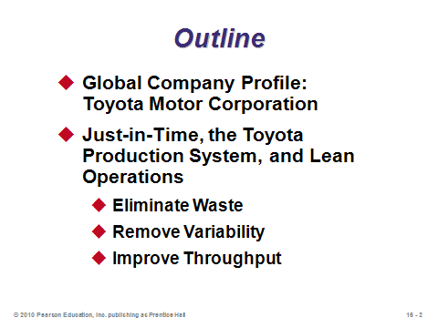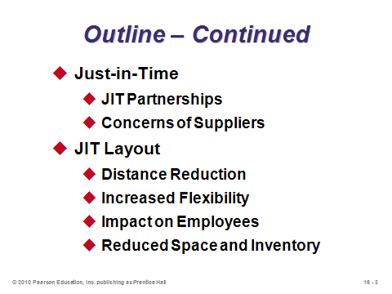

**16-1 16-2 16-3**

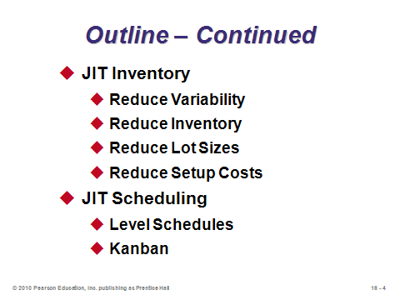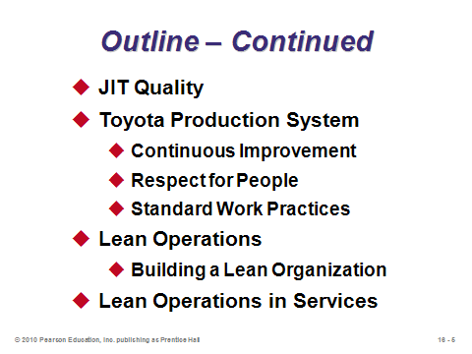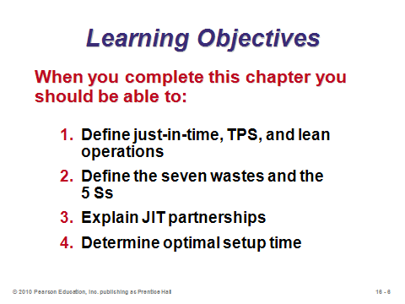

**16-4 16-5 16-6**

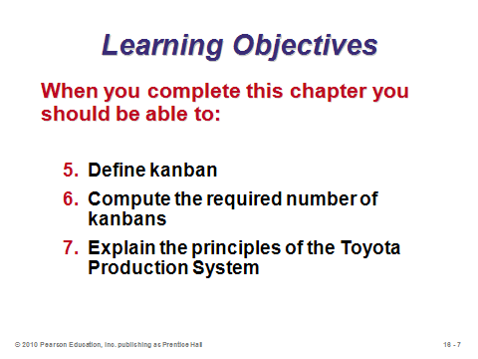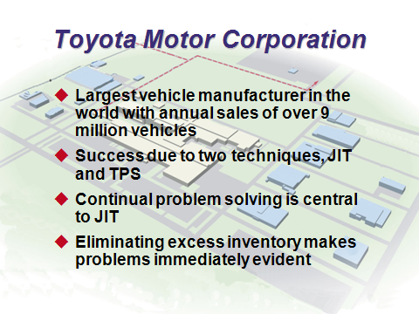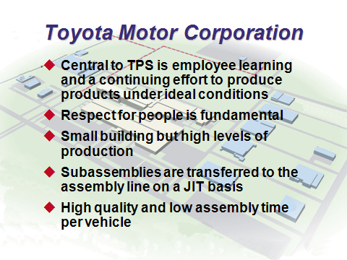

**16-7 16-8 16-9**

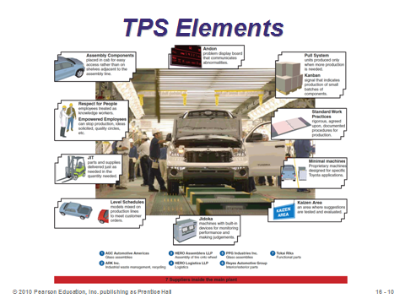

**16-10**

JUST-IN-TIME, THE TOYOTA PRODUCTION SYSTEM, AND LEAN OPERATIONS

(16-11 through 16-23)

Slides 11-13: Over the years, various authors, consultants, and companies have coined new terms that sometimes primarily repackage old concepts. Much of the content today in JIT, TPS, lean, and six sigma programs is based on total quality management principles developed by Deming and others more than 50 years ago (Chapter 6). As these three slides indicate, the distinctions among some of these strategies are not always clear, and their goals are usually very similar. Nevertheless, they all bring added value to our collective knowledge of how to run an operation efficiently. This chapter describes JIT, TPS, and lean operations in detail.

Slides 14-15: All non-value-added activities are considered to be *waste*. Taiichi Ohno has identified seven such categories of waste (Slide 15).

Slide 16: Waste is sometimes more broadly defined as the waste of any resources, such as air, energy, and water. This kind of waste can be reduced or eliminated via efficient, sustainable production.

Slides 17-18: The Japanese developed the initial 5 Ss, representing a good checklist for lean operations (Slide 17). U.S. managers added two more (Slide 18).

Slides 19-21: Management would be simple if there were no variability. Slide 20 identifies three of the many possible sources of variability. Slide 21 tells us that JIT and inventory reduction can act like magnifying glasses, exposing the causes of variability. Once the causes are known, corrective action can be taken.

Slides 22-23: A technique for improving throughput is a *pull system*, a concept that results in material being produced only when requested and moved to where it is needed just as it is needed. Pull systems are a standard tool of JIT systems.

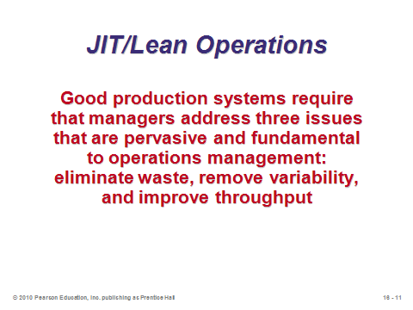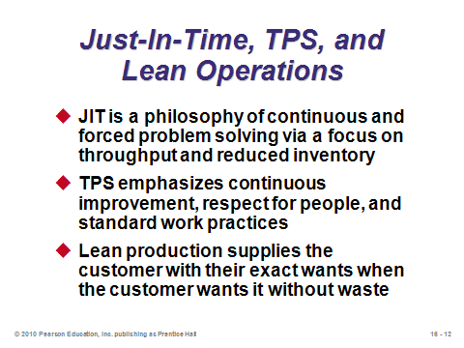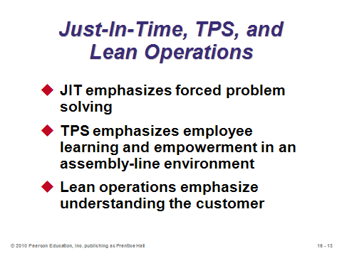

**16-11 16-12 16-13**

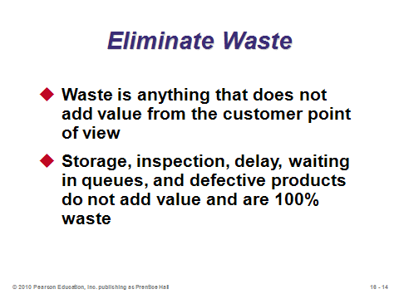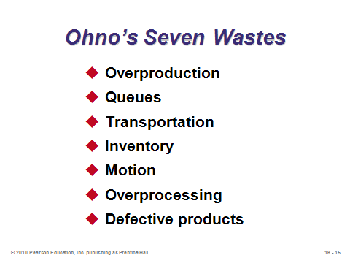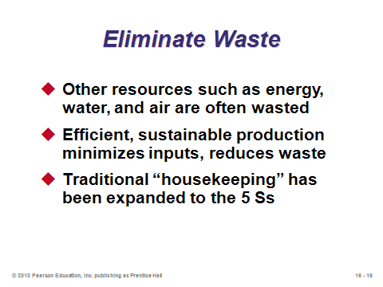

**16-14 16-15 16-16**

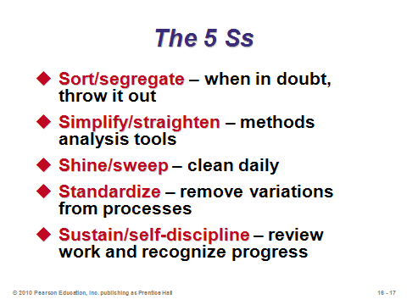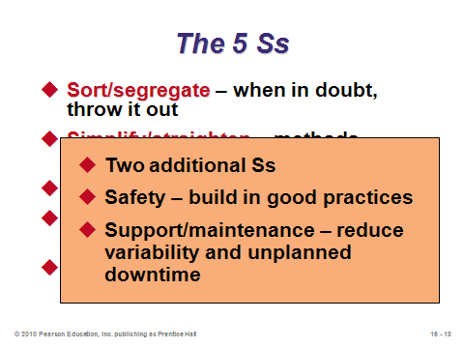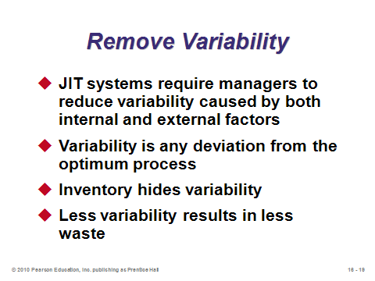

**16-17 16-18 16-19**

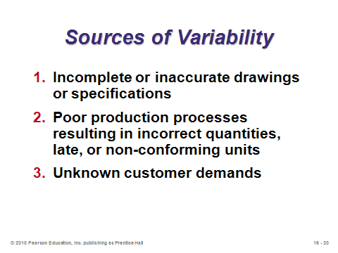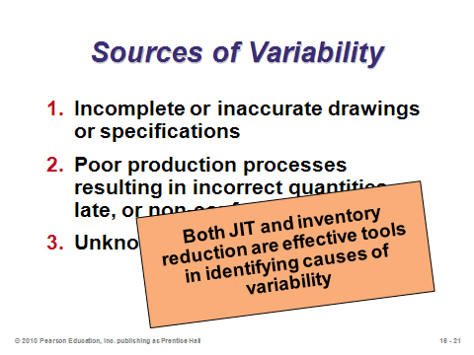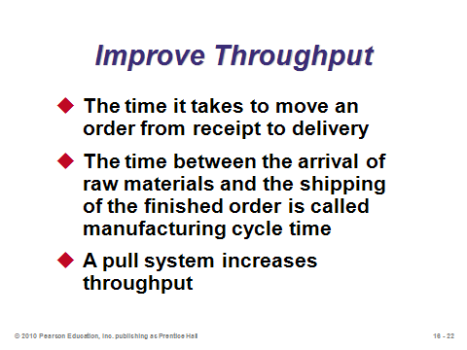

**16-20 16-21 16-22**

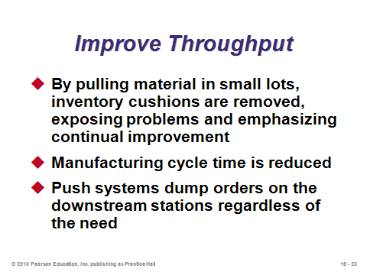

**16-23**

JUST-IN-TIME (JIT) (16-24 through 16-29)

Slide 24: This slide describes some of the most important aspects of JIT.

Slides 25-26: These slides reproduce Figure 16.1 from the text, showing how JIT contributes to competitive advantage.

Slides 27-28: True JIT cannot exist unless it extends beyond the company such that the suppliers deliver parts just-in-time. Often a large buying firm will offer “free” consulting services to its suppliers to try to help improve their processes and make them capable of delivering just-in-time. For example, complete incoming inspection does not mesh well with JIT deliveries. The buyer would like to be convinced that the supplier has sufficient statistical process control and inspection systems in place so that the buyer can take the supplier’s parts right of the truck and straight onto the assembly line. Slide 28 (Figure 16.2) displays the many characteristics of JIT partnerships. An important one is that in many cases, suppliers open factories very close to the buyer’s factories to ease communication and make frequent deliveries of small lots sizes economically viable. In fact, some large Japanese firms have been known to subsidize the location costs of some of their major suppliers when opening a new factory abroad.

Slide 29: Instructors should spend a fair amount of time on this slide because proper supplier integration is absolutely crucial for a successful JIT program. And vendors may be essentially forced to become JIT suppliers for large manufacturers if they want to supply those manufacturers at all. The promise of a lot of sales potentially comes with significant risks and costs, particularly if the supplier is not currently JIT-capable. The last bullet on this slide, in particular, is a common criticism of JIT. If the supplier does not have JIT capability itself, or if its production process possesses significant economies of scale, then the supplier may have to hold a significant amount of finished goods inventory to be able to respond quickly to JIT orders. Seen this way, EOQ-based inventory normally held at the manufacturer’s plant is simply moved to the supplier’s plant, along with the associated holding costs.

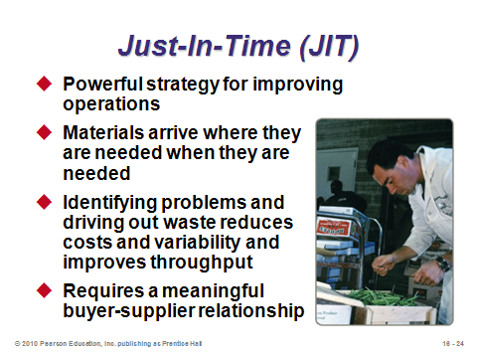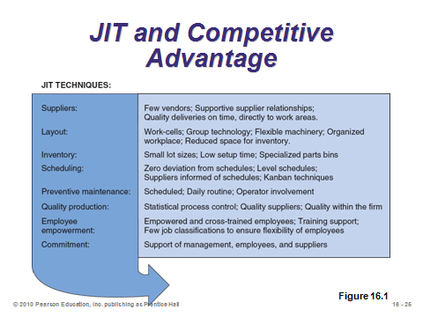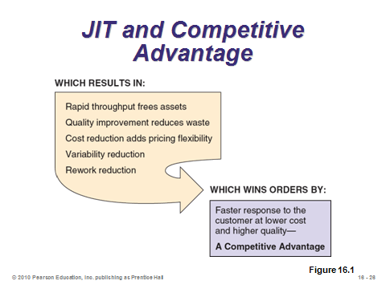

**16-24 16-25 16-26**

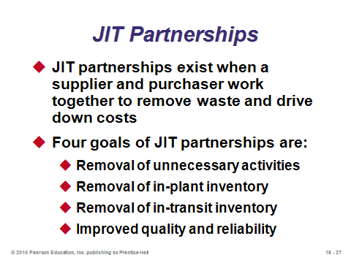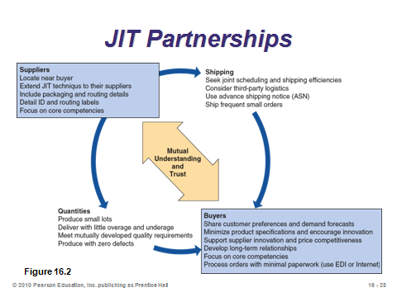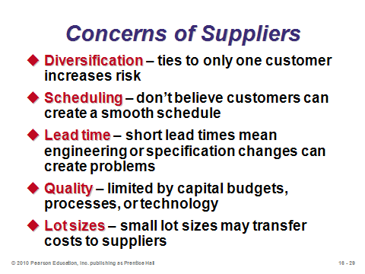

**16-27 16-28 16-29**

JIT LAYOUT (16-30 through 16-45)

Slide 30: A properly designed layout can significantly help firms reach their JIT goals, particularly by removing the waste of excess movement. This slide (Table 16.1) identifies several proven tactics for JIT layout.

Slide 31: Work cells were discussed in detail in Chapter 9, and such arrangements often work very well for companies implementing JIT. Instructors can emphasize here why the U-shape makes sense under these conditions. With JIT, every machine is not necessarily working all of the time (as they might be in a traditional assembly line). Thus, these work cells often can be operated by fewer workers than machines. The workers are flexible and can operate all of the machines in the cell. Therefore, the U-shape helps these workers observe all of the machines better and move between them much faster as distance may be cut by half or more as compared to a linear layout.

Slide 32: Almost nothing in these new departments is bolted down. Most machines, furniture, office equipment, walls, and electronic/communications connections are movable. This type of flexibility is crucial in an environment of continuous improvement.

Slide 33: Clearly, workers in a JIT environment have more job enlargement, enrichment, and empowerment (Chapter 10) than workers in a traditional assembly line do. Traditional union rules requiring very specific job classifications would not work well in a JIT system. Along with the broader job tasks of JIT comes the responsibility for quality control and making it right the first time. There is no safety stock to replace defects on the fly.

Slide 34: This slide presents a visual inventory-reduction tactic: remove the storage space. It may sound simple, but humans tend to fill empty spaces with “stuff.” If little storage space is available, then systems must be designed to minimize inventory levels or else inventory will be left on the machines, blocking other products from being produced. (This concept relates well to the gel packs in the Arnold Palmer Hospital video where hospital space is a premium.)

Slides 35-39: Inventory reduction arguably represents the most powerful impact of moving to a JIT system. Slide 35 (Table 16.2) identifies tactics for reducing inventory. Slides 36-39 describe the famous inventory boat analogy (Figure 16.3). We see in these three pictures that inventory (the water level) acts as a double-edged sword. In the short run, it may provide “smooth sailing” over the company’s problems (the rocks). But in the long run, not only is the inventory itself expensive, but it hides the underlying problems with the operation, and those associated costs continue to be incurred. A similar analogy can be described using a bandage covering an infected wound. The bandage might stop the bleeding, but if it hides the infection from being noticed, then the wounded person will have a lot more problems later on.

Slides 40-45: Having learned all about the EOQ and POQ from Chapter 12, students may wonder how to reconcile the potentially large lot sizes computed there with the JIT philosophy of small batches. Were the formulas wrong? Are the JIT proponents naive by ignoring relevant costs? The answer is that both approaches come together when we think of the setup cost *S* as a variable instead of a parameter. (This is arguably the most important contribution from the Japanese JIT philosophies.) By reducing the setup cost towards zero (potentially through some sort of initial investment in process change), the EOQ (POQ) lot size will approach 1. Slide 42 (Example 1) turns the POQ formula around such to find the necessary setup cost (time), given a target order quantity. From there, the firm can work on methods to reduce *S* to the required amount. Slide 45 (Figure 16.6) provides steps for reducing setup times.

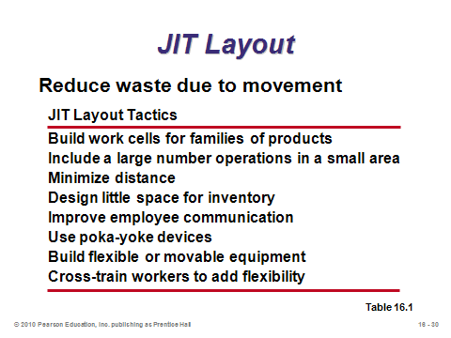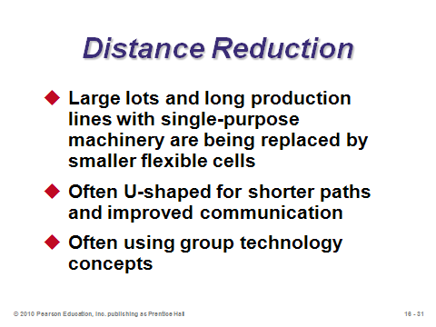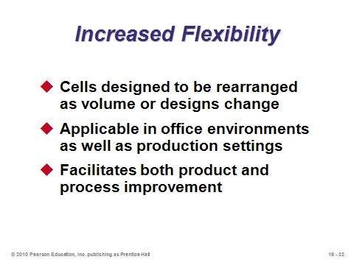

**16-30 16-31 16-32**

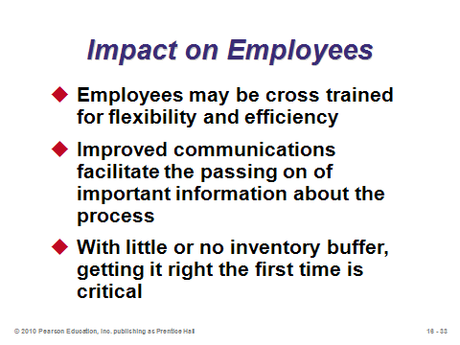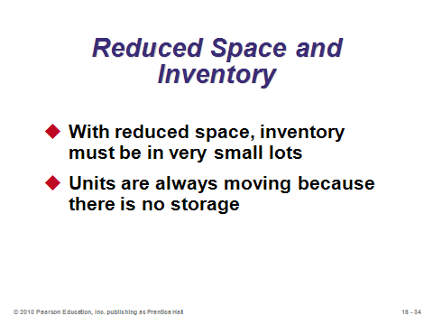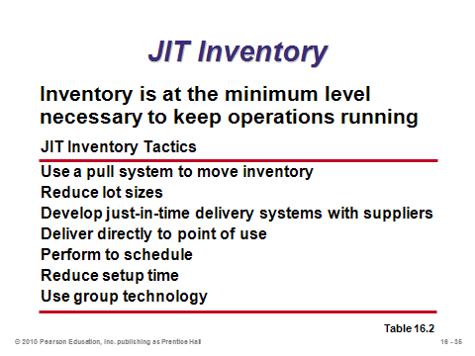

**16-33 16-34 16-35**

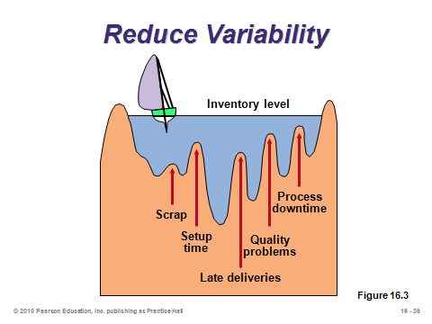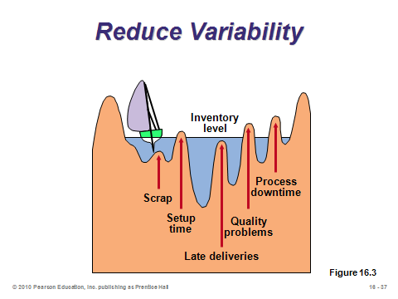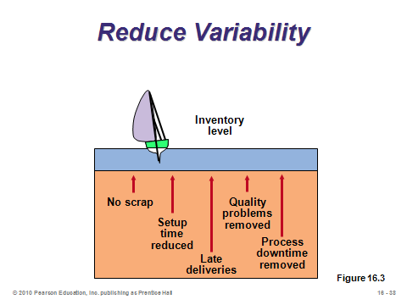

**16-36 16-37 16-38**

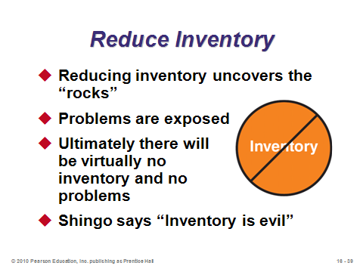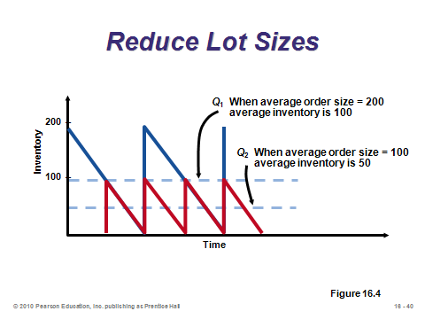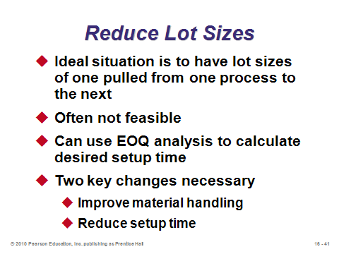

**16-39 16-40 16-41**

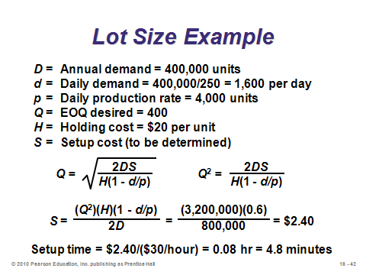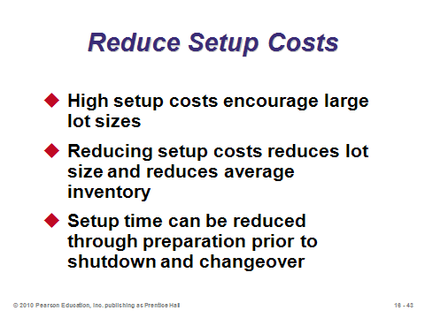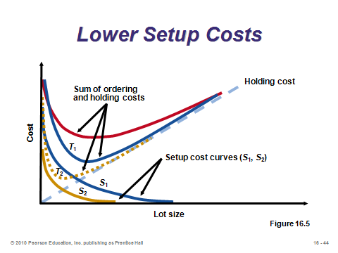

**16-42 16-43 16-44**

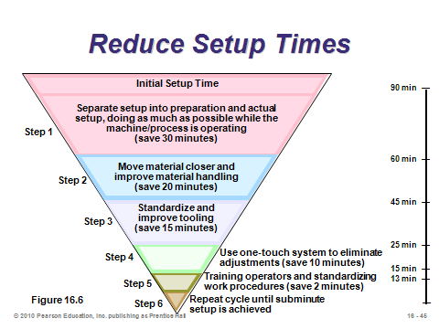

**16-45**

JIT SCHEDULING (16-46 through 16-58)

Slides 46-49: Slide 47 identifies tactics for JIT scheduling, the two most important of which (in addition to communicating schedules to suppliers) are *level schedules* and *kanban*. JIT does not perform well with highly variable schedules because the system cannot react quickly enough to major swings in demand. Thus, level schedules are a prerequisite for effective JIT (Slide 48). Sometimes firms freeze the schedules for a certain period of time to keep them stable. Level scheduling is sometimes referred to as “jelly bean” scheduling because this technique schedules many small lots that are always changing (see Slide 49, modified from Figure 16.7).

Slides 50-58: These slides present information about *kanbans* (pronounced “kahn-bahn,” not “can-ban”), which are the signaling mechanisms in JIT systems. A distinctive feature of JIT production is that if a kanban has not been received, then the work station sits idle, going against the traditional philosophy of maximizing utilization rates at all stations. Note that the kanban does not have to be a physical card. As Slide 51 (Figure 16.8) shows, any effective signaling mechanism will do. Slide 52 (Figure 16.9) illustrates how kanban cards are used to pull material through an entire production process. Slides 53-55 provide additional implementation specifics about kanbans. Slide 56 provides the formula for determine the number of kanbans or containers needed for moving back and forth between the using area and the producing area. The size of each container is based on a lot-sizing model such as the POQ (Chapter 12 and Equation (16-1)). Slide 57 (Example 2) provides a example for computing the number of kanbans. Slide 58 identifies several advantages of kanban systems, realized in part because kanban containers are typically very small, usually a matter of a few hours’ worth of production.

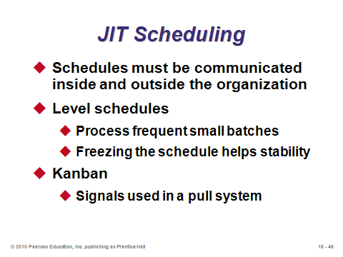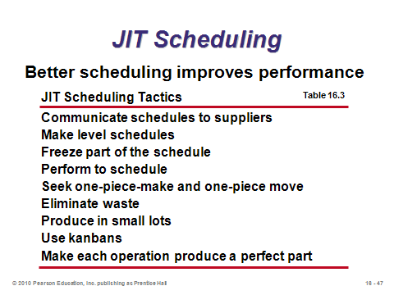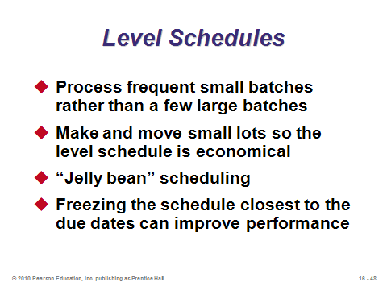

**16-46 16-47 16-48**

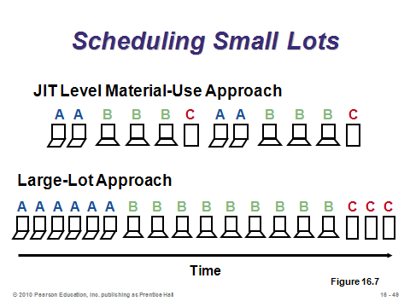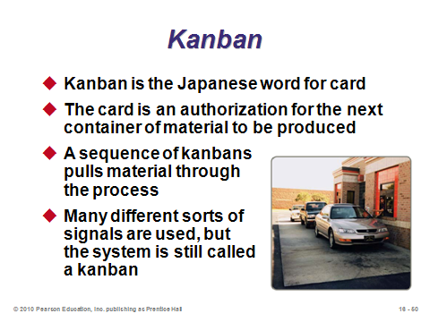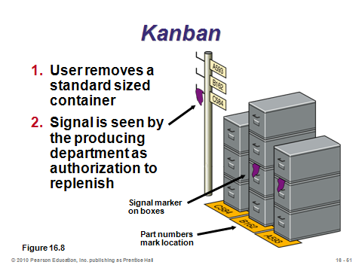

**16-49 16-50 16-51**

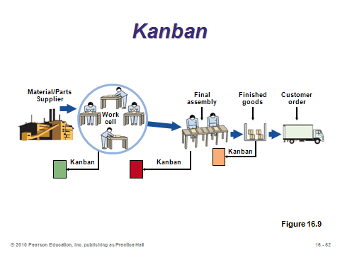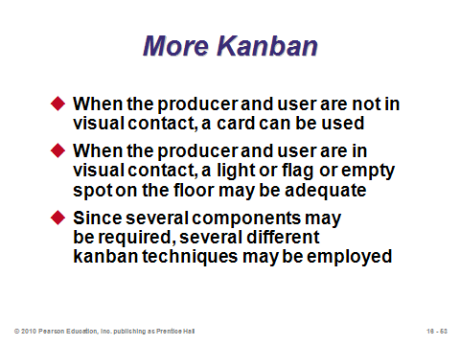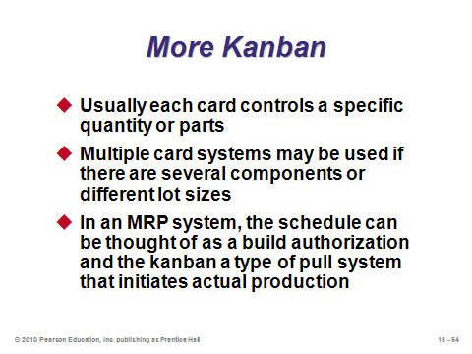

**16-52 16-53 16-54**

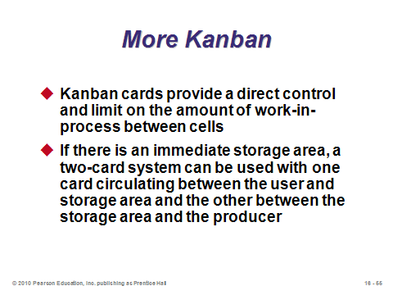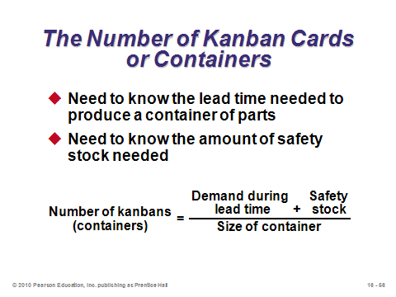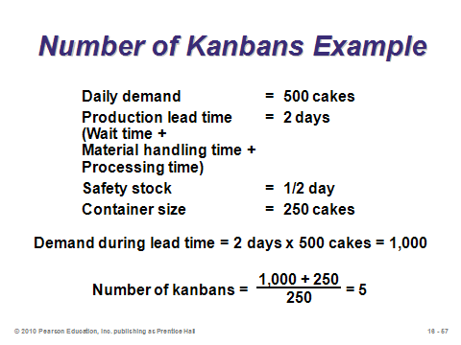

**16-55 16-56 16-57**

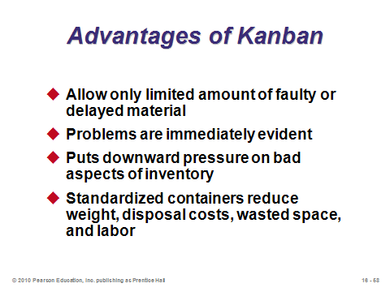

**16-58**

JIT QUALITY (16-59 through 16-60)

Slide 59: This slide presents three ways in which JIT and quality are directly related.

Slide 60: This slide (Table 16.4) presents several JIT quality tactics.

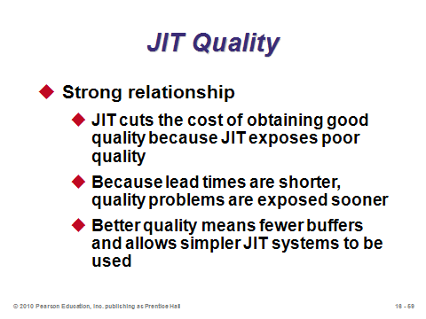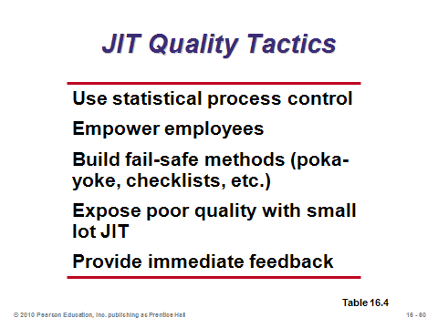

**16-59 16-60**

TOYOTA PRODUCTION SYSTEM (16-61 through 16-62)

Slides 61-62: The Toyota Production System (TPS) (recall Slide 10) “brings the entire person to work.” Three core components of TPS: continuous improvement, respect for people, and standard work practice, are described in these slides. TPS requires that activities, connections, and flows include built-in tests to automatically signal problems. Any gap between what is expected and what occurs becomes immediately evident.

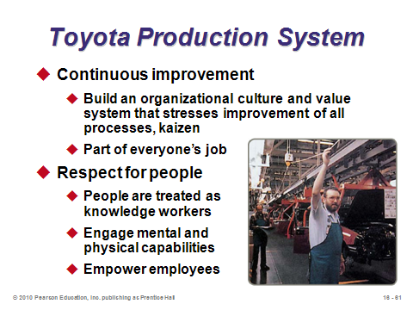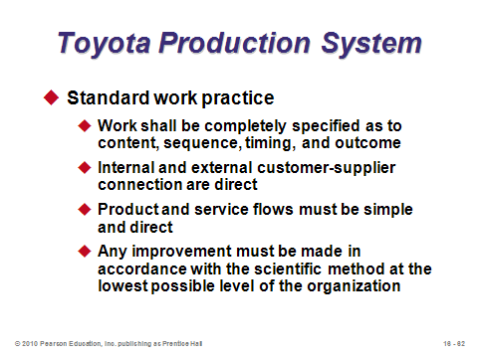

**16-61 16-62**

LEAN OPERATIONS (16-63 through 16-65)

Slides 63-65: Lean production can be thought of as the end result of a well-run OM function. While JIT and TPS tend to have an *internal* focus, lean production begins *externally* with a focus on the customer (Slide 63). Slides 64 and 65 identify several attributes that tend to exist in lean systems.

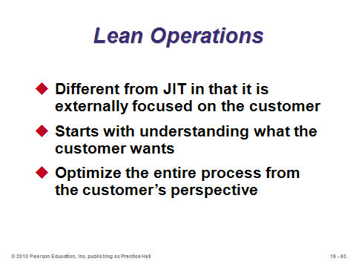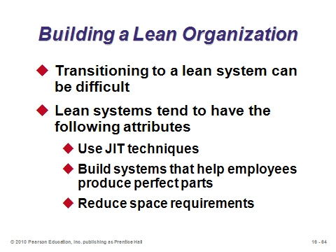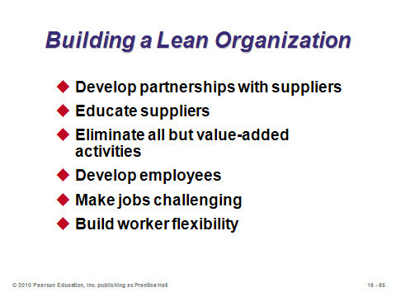

**16-63 16-64 16-65**

LEAN OPERATIONS IN SERVICES (16-66)

Slide 66: This slide identifies example areas where lean techniques apply to services. First, virtually every restaurant deals with its suppliers on a JIT basis due to the perishability of the inventory. Second, lean layouts are required in restaurant kitchens, where cold food must be served cold and hot food hot. Third, McDonald’s reduces inventory waste by maintaining a finished-goods inventory of only 10 minutes; after that, it is thrown away. Fourth, at airline ticket counters, ticket counter personnel show up just-in-time to cover peaks in customer demand.

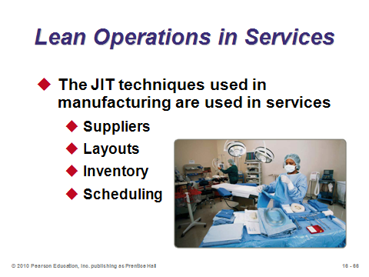

**16-66**

**Additional Assignment Ideas**

1. Boeing has proudly emphasized its lean practices for several years. Research the company and write a report describing some of the lean practices in place at Boeing.

2. Imagine you are a manager at a just-in-time manufacturing plant, and you are concerned about parts arriving on time. Visit the Roadway Express Web site at www.roadway.com. Describe Roadway's solution. Do they offer any innovative approaches to this situation?

**Additional Case Studies**

Harvard Case Studies (http://harvardbusinessonline.hbsp.harvard.edu)

* *Johnson Controls Automotive Systems Group: The Georgetown Kentucky Plant* (#693-086): Examines the challenge of JIT with growing variation and a change from JIT delivery to JIT assembly.
* *Injex Industries* (#697-003): Examines supplier concerns as Injex provides components to a single, demanding customer on a JIT basis.

Richard Ivey School of Business (http://cases.ivey.uwo.ca/cases/pages/home.aspx)

* *Spartan Plastics* (#9A97D012): This case would be appropriate to introduce students to the concepts of JIT and world-class manufacturing.
* *VBF Tubing* (#9A97D011): VBF Tubing, a Dutch firm, is facing increased demand for its products, high inventory levels, and expensive setup costs. In light of these problems, the logistics manager must decide how to respond to a proposal that longer production runs be scheduled.

**Internet Resources**

|  |  |
| --- | --- |
| Business Open Learning Archive, UK | www.bola.biz/index.html |
| Gemba Research | www.gemba.com |
| Kanban—and the environment | www.epa.gov/lean/thinking/kanban.htm |
| Kanban—explanation | www.graphicproducts.com/tutorials/kanban/index.php |
| Manufacturing Engineering | www.mfgeng.com |
| Mid-America Manufacturing Technology Center | www.mamtc.com |
| Toyota Motor Corp. | www.toyota.co.jp/en/vision/production_system |

**Other Supplementary Material**

Learning Game

Lean Games and Tools (<http://www.leanshopping.com>):

Downloadable versions of FlowBoat and FlowCar

Videos

Films available from:

Society of Manufacturing Engineers

One SME Drive

P.O. Box 930

Dearborn, Michigan 48121-0930

(P) 313-425-3000

(F) 313-425-3412

http ://www.sme.org

* *MI #21 Implementing Just-in-Time*, SME Video Network
* *Flexible Small Lot Production for JIT*-See how Roll Forming Corp., Joy Technologies, and Lockheed Aeronautical Systems Company are able to do this. Order # PI-VT415-3456
* *Implementing Just-in-Time*-See how Opcon, Zytec, Hayes Industrial Brake, and Manufacturing Solutions were able to do this. Order # PI-VT284-3456

Film available from:

APICS

http://www.apics.org/Bookstore/

* *Styro, Inc.*-- John Deere Components Works (Stock # 01201) distributed through APICS. It is a wonderful illustration of many just-in-time concepts. This 36-minute video demonstrates the concept of value-centered manufacturing, which is aimed at adding value—not cost—to the product while fulfilling customer demands.

Poetry

Instructors with a poetic bent might recite the poem called, “An Ambulance Down in the Valley,” which is available in various forms on several websites (e.g., http://www.wealthandwant.com/docs/ Malins_ambulance.html). The analogy here is that the ambulance is equivalent to inventory in the factory.

Excerpts:

“Twas a dangerous cliff as they freely confessed,

Though to walk near its edge was so pleasant.

But over its edge had slipped a Duke,

And it fooled many a peasant.

The people said something would have to be done,

But their projects did not at all tally.

Some said, ‘Put a fence around the edge of the cliff,’

Others, ‘An ambulance down in the valley.’

Yes, build up the fence and let us dispense,

With this ambulance down in the valley.”